LINK TO COMMONWEALTH WAR GRAVES COMMISSION (C.W.G.C.)
Serjeant Edwin Leslie Flexman | War Casualty Details 253034 | CWGC

Edwin Leslie Flexman was born in 1889 at Fulham and was the first child of six, of William James and Matilda, formerly Croucher. His siblings were Frederick born 1891, Winifred Julia born 1893, Constance Dorothy born 1898 and William James (Jr) born about 1906.

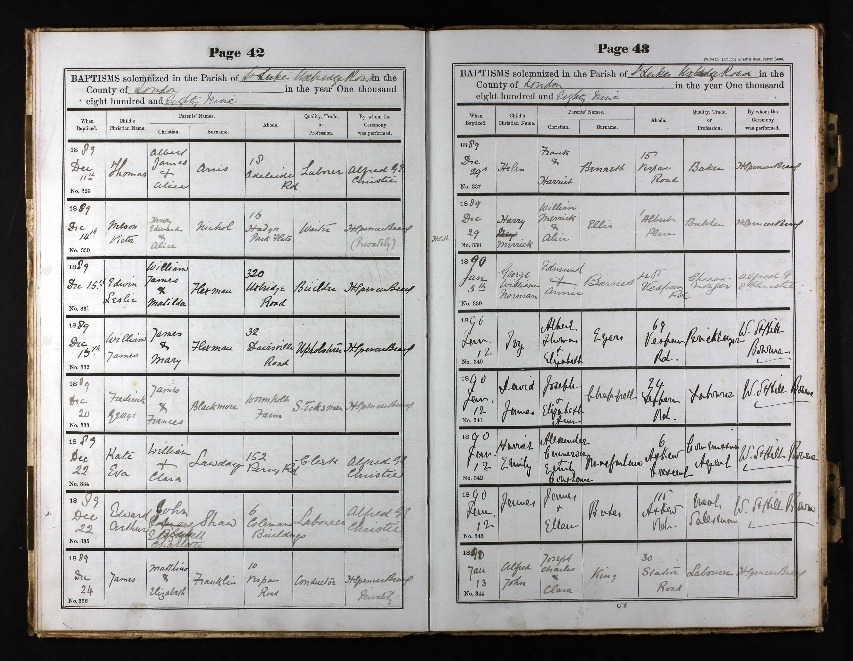

Census records for 1871 to 1891 show William James (Snr) as being born in
Chelsea about 1861 and Matilda in Strood Kent about 1869 although different places
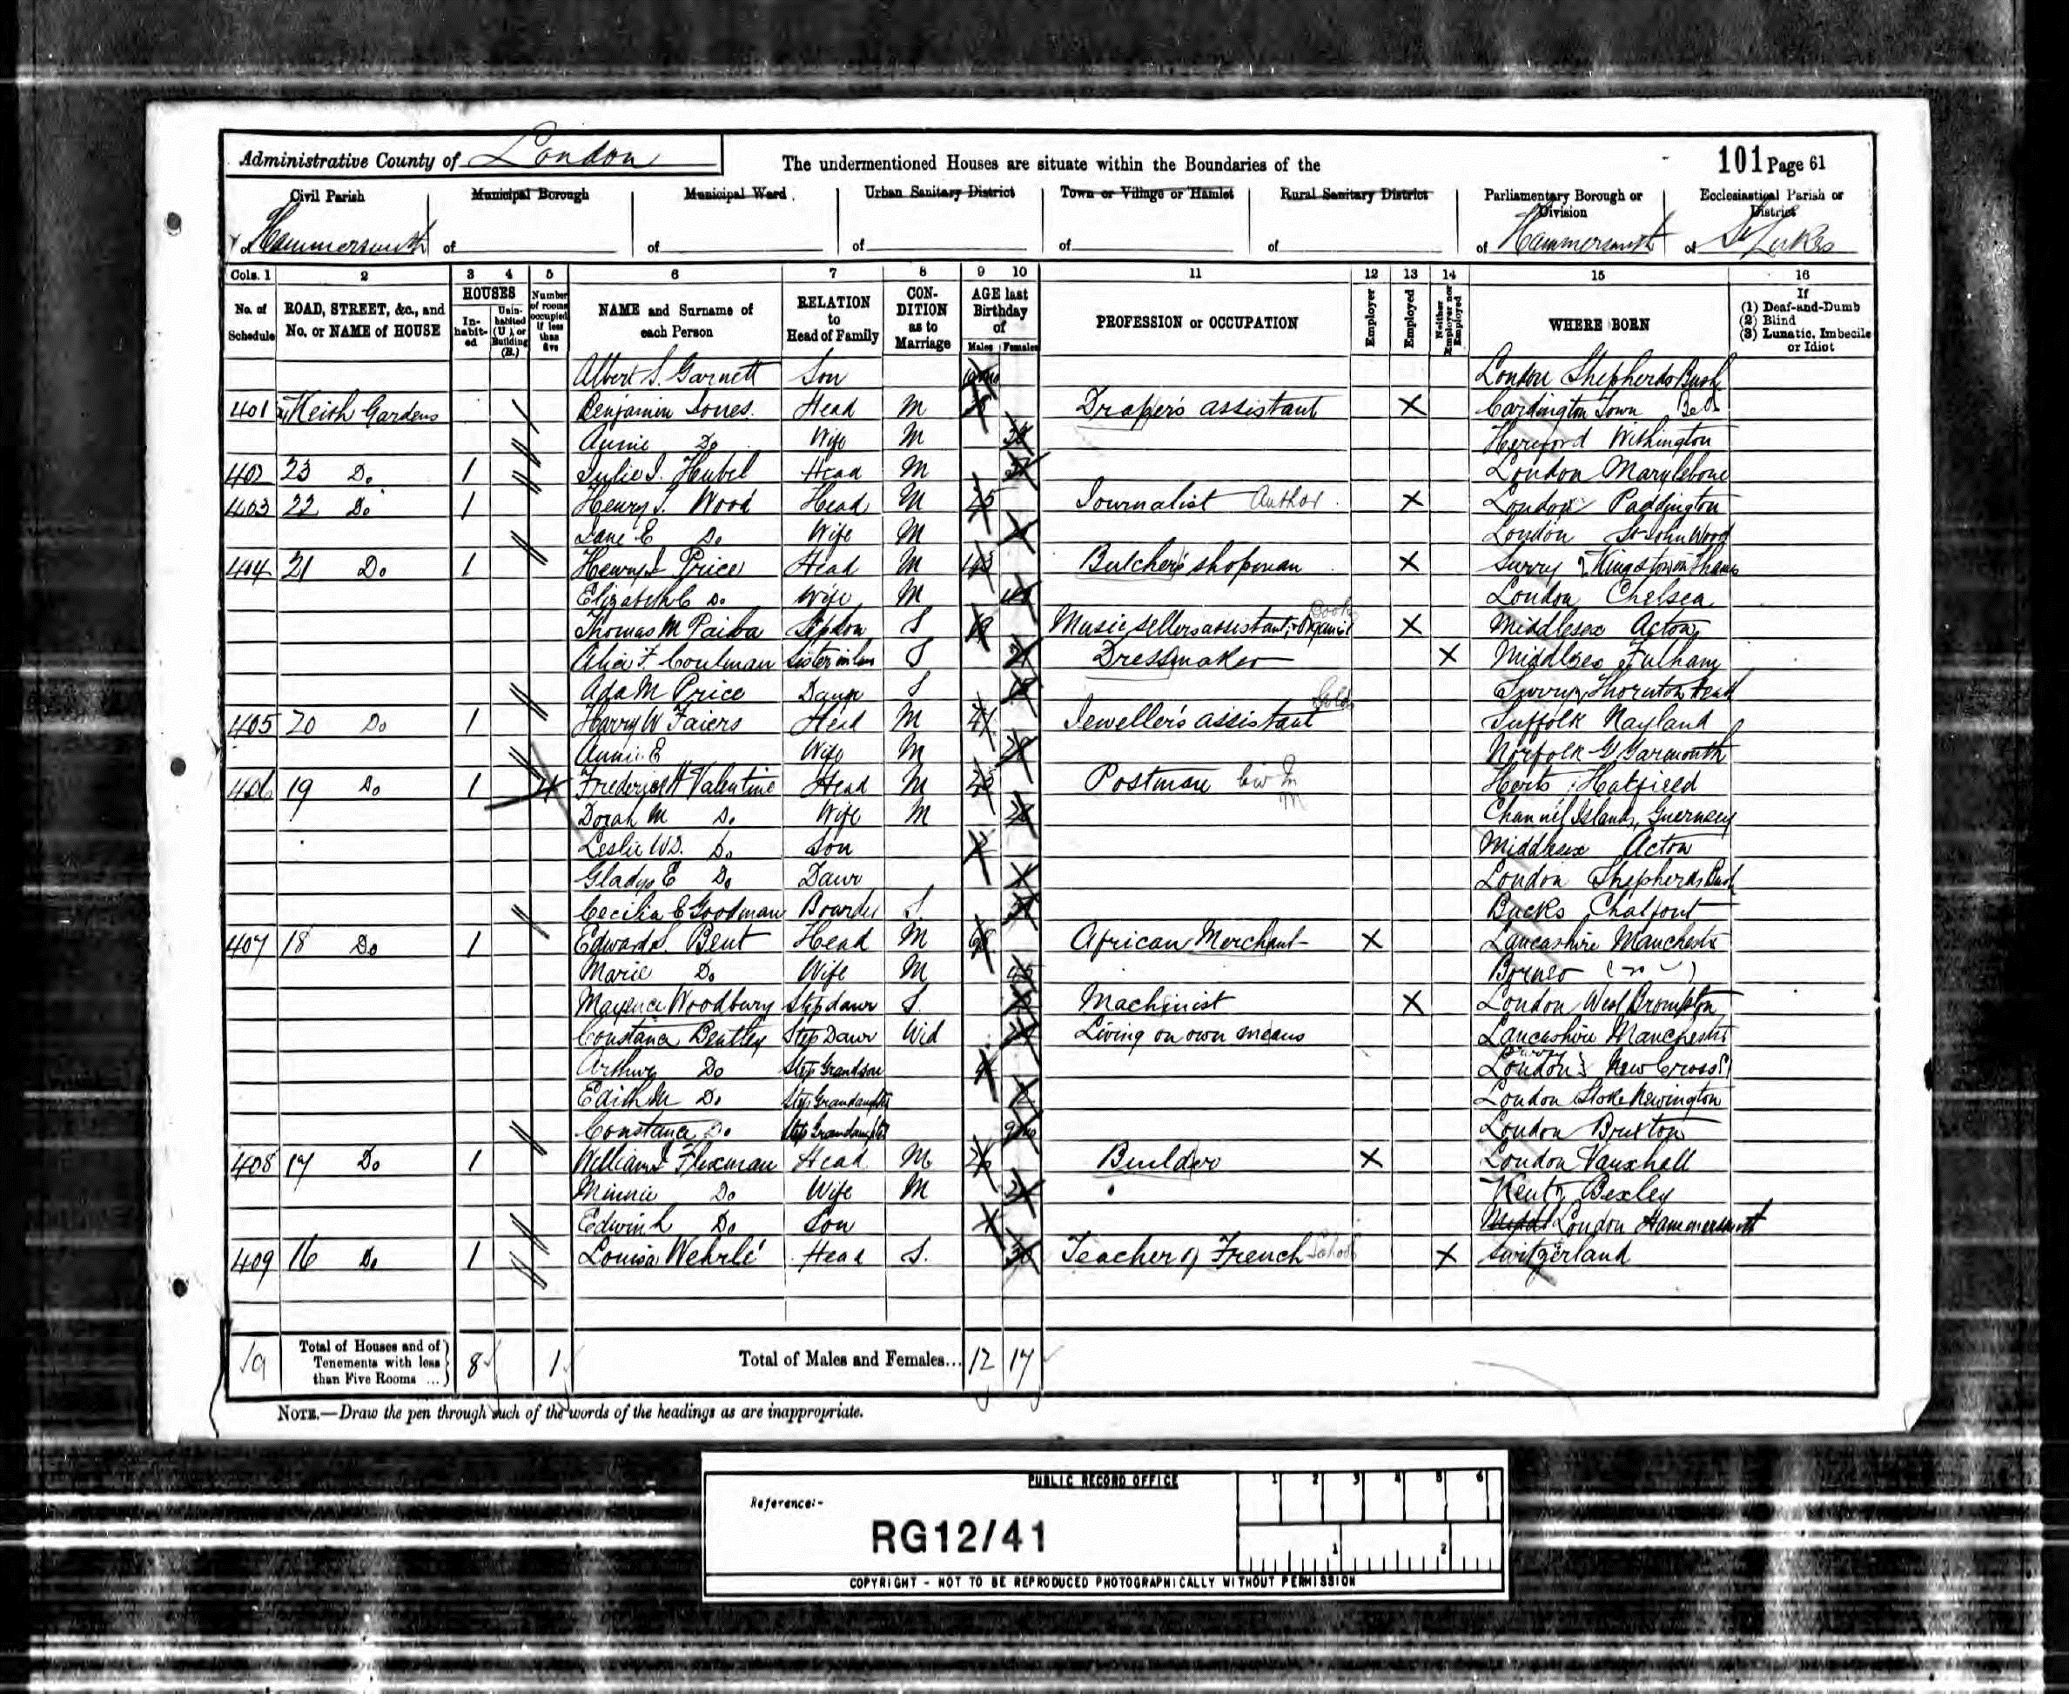E

Edwin appears on the 1901 census together with his mother but not his father. By
1911 his father is resident in Sussex but Edwin and his mother are still in London.
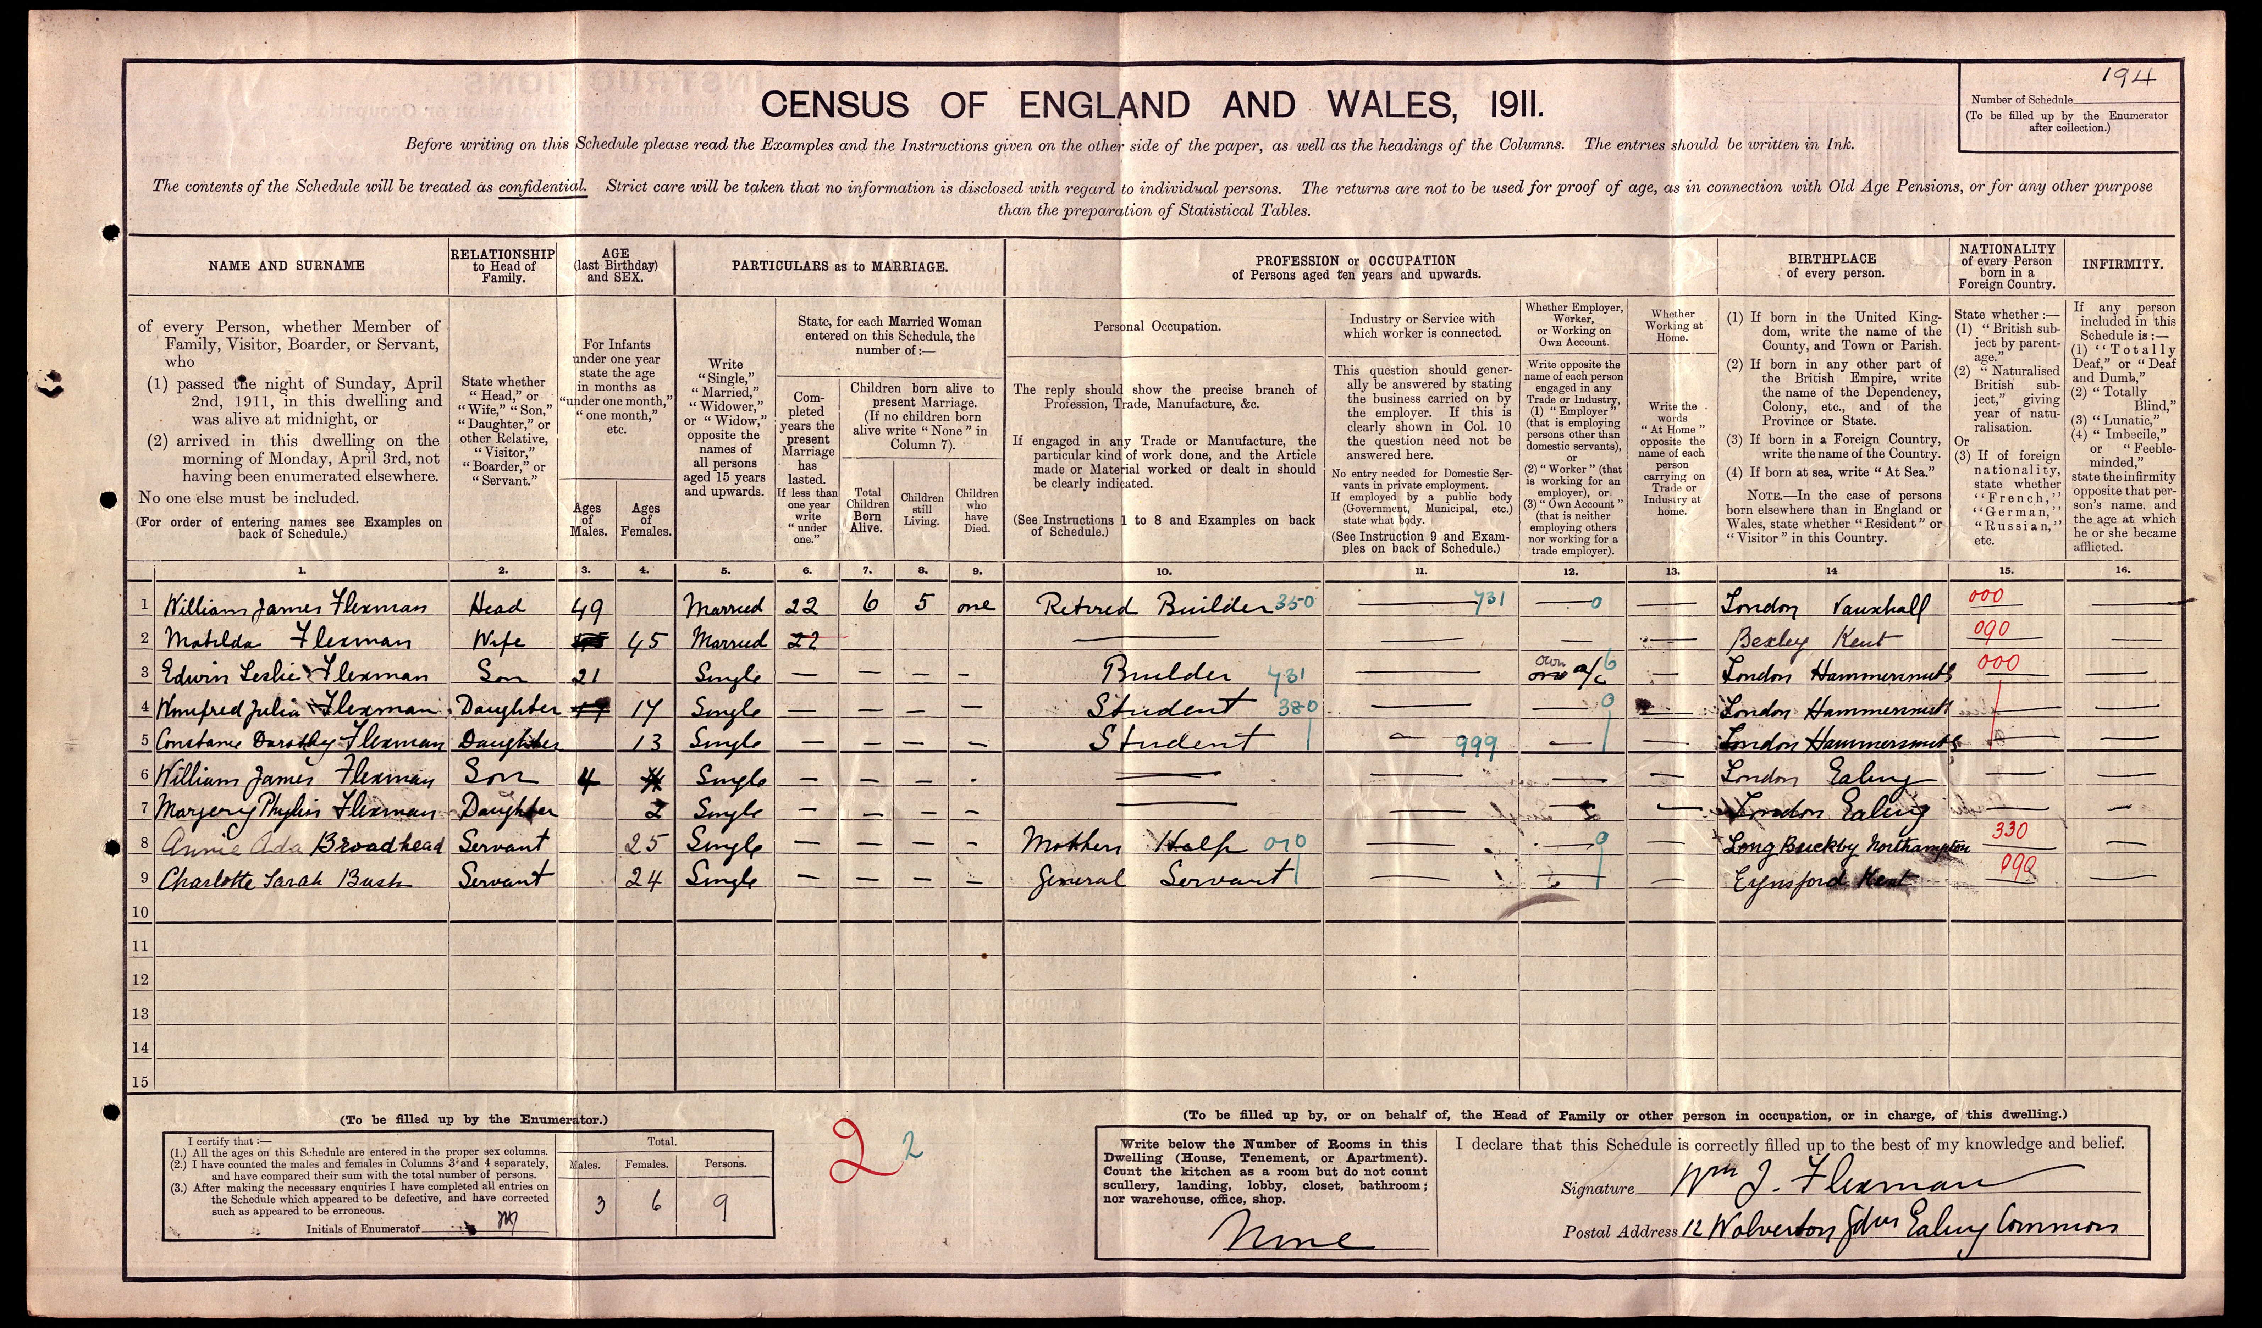
Edwin Leslie Flexman of Mill Cottage, Felpham Bognor in the County of Sussex, a Serjeant in the 2nd/1st West Kent Yeomanry stationed at Woodbridge in the County of Suffolk left in his will, dated 10th December 1916, all his personal estate to his wife Mary Deane formerly Sharp(e) and to any children that they might have. The value of his estate was £1,286 1s which is currently estimated to be about £120,000, over 9,000 % increase. Mill Cottage is now Mill House and is on the corner of Sea Road and Canning Road.
He had married Mary in 1916 at Brentford. Their son John D. was born in 1918.
He was transferred from the Yeomanry, which stayed in the U.K. for the duration of the war, into the Infantry probably in 1917 when there was a reorganisation of the Yeomanry. There are no details about his service on his record cards from The National Archives with any other units than the 7th Battalion West Kents except "TF" (Teritorial Force) against his award of the Victory and British War medals.
205341 Serjeant Edwin Leslie Flexman died on 24th April 1918 whilst serving with the 7th (Service Battalion) Queen's Own Royal West Kent Regiment. He was 28. He is buried in Crucifix Corner Cemetery, Villers-Bretonneux, Somme, France, grave I.C.3.
The battles for Villers-Bretonneux were fought during the German Spring Offensive of 1918 which began on 21st March 1918, and within two weeks German troops had advanced over 50 kilometres.
The Germans intended to capture the vital Allied city of Amiens. Their advance was halted just 10 kilometres from Amiens by British and Australian troops on 4/5th April 1918 at the French town of Villers-Bretonneux.

In the early hours of 24th April the Germans launched a surprise attack against the defenders of Villers-Bretonneux, and German infantry, supported by tanks, overran the Allied defences.

During the fierce fighting on 24th April a British Mark IV tank, No.4066, opened fire on ‘Nixe’, a German A7V tank. This is believed to be the first tank versus tank engagement in history.

In a daring night attack on 24/25th April the Australian 5th Division,with supporting British units, counter-attacked. By dawn the Germans had been driven from the town and their progress towards Amiens had finally been stopped for good.

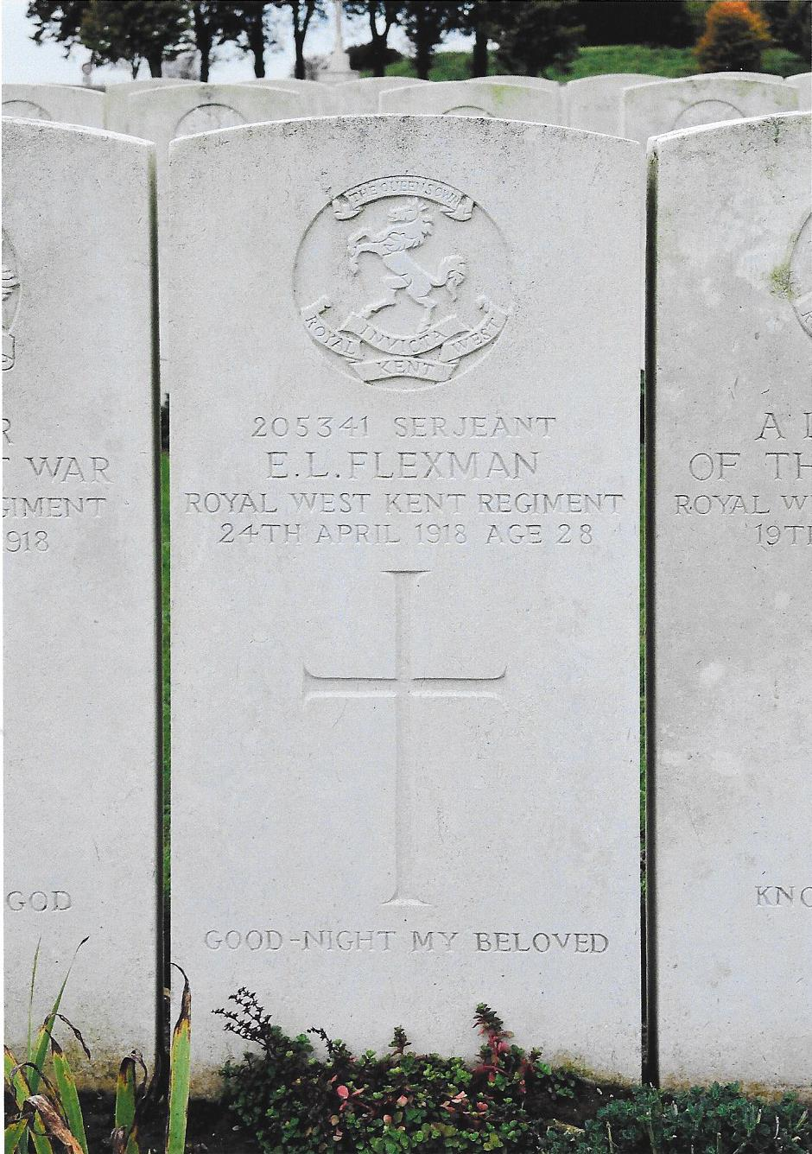
Gravemarker of Edwin Leslie FLEXMAN

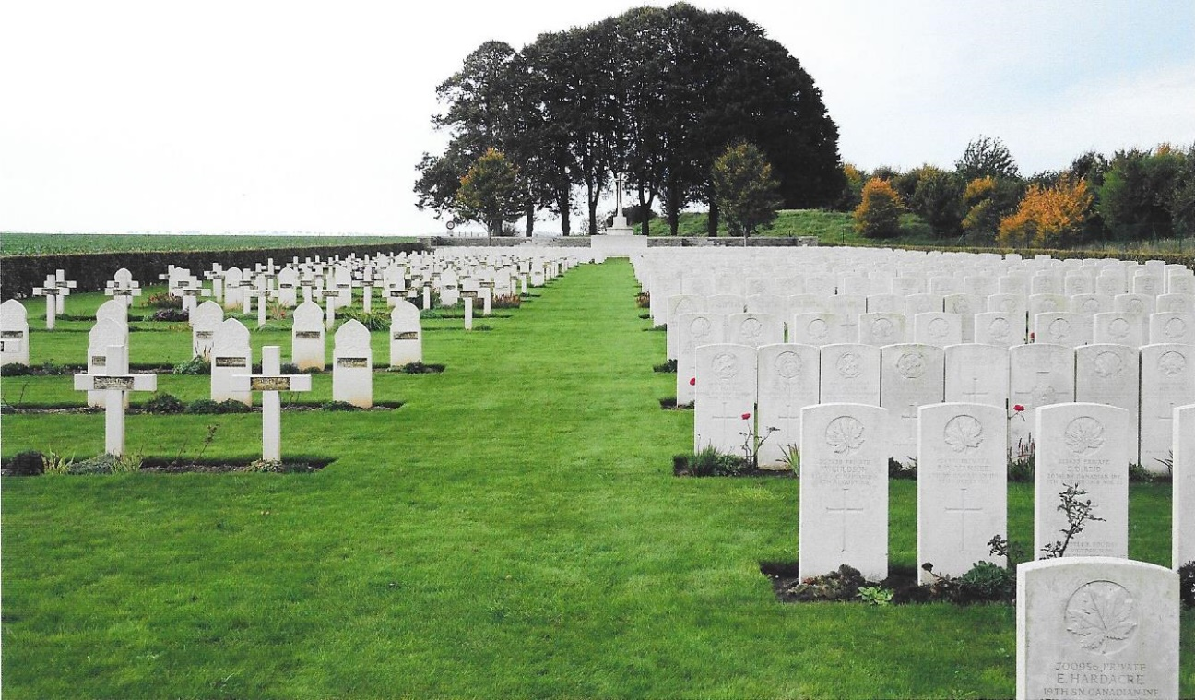
Crucifix Corner Cemetery Villers Bretonneux France

Medal Index Roll showing indivoduals entitled to the
Victory medal and British War medal.
Sjt Flexman is 4th from bottom of the page

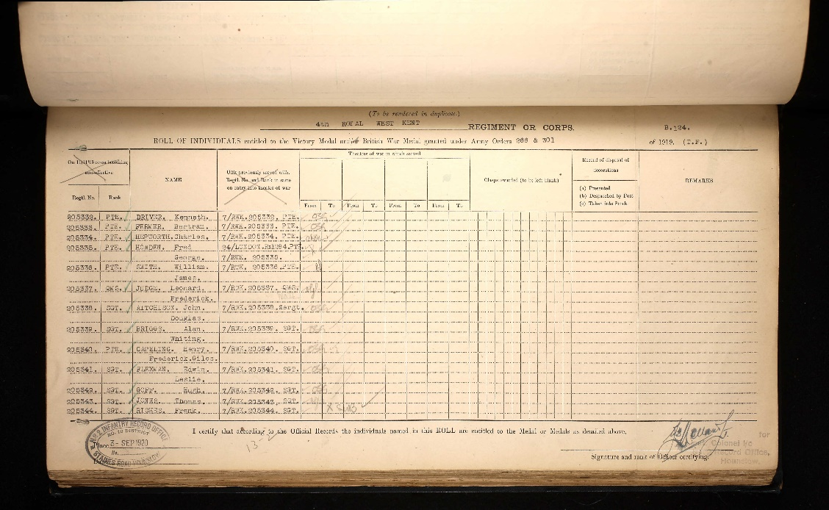
Soldier’s Effects
7th Bn. Royal West Kent Regiment; in action or died of wounds; credits £5 9s 4d plus £20 to widow Mary D.
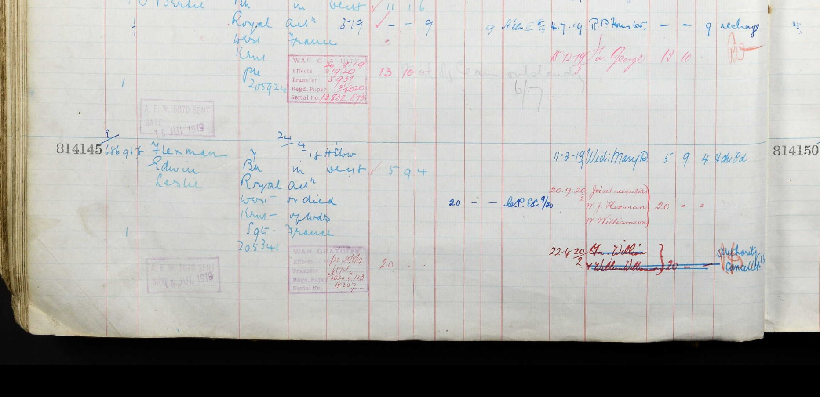

THIS IS THE LAST WILL AND TESTAMENT of me EDWIN LESLIE FLEXMAN of Mill Cottage, Felpham Bognor in the County of Sussex, a Serjeant in the 2/1st West Kent Yeomanry stationed at Woodbridge in the County of Suffolk I revoke all former and other Wills Codicils and Testamentary dispositions and appointments whatsoever by me at any time heretofore made and declare this to be my last Will and Testament I appoint my Father William James Flexman of 12 Wolverton Gardens, Ealing Common and my Brother-in- law William Williamson of 12 Cecil Park Pinner to be the EXECUTORS of this my Will and Trustees of my Estate I give devise and bequeath all my real and personal estate of whatsoever nature and kind and wheresoever situate unto my Trustees Upon Trust to sell and convert into money such real and personal estate at such time and in such manner as they in their absolute discretion may think fit or expedient and to invest the net sum or sums of money thus arising in the names of my Trustees in or upon the Public Stocks Funds or securities of the United Kingdom or on any real securities in the United Kingdom and to vary the investments from time to time for any other of like nature and to pay the annual income thereof to my dear Wife Mary Dene Flexman during her life and after her decease then (but subject to any advancements and payments as hereinafter provided) as to the whole of the said trust fund both capital and income Upon trust for all my children (if any) who shall be living at her death who being sons or a son shall attain the age of twenty one years or being a Daughter or Daughters shall attain that age or marry and if more than one in equal shares but if there shall be only one child living at the decease of my said Wife as aforesaid then the whole of the said Trust Fund both capital and income shall belong to that one child only I declare that if there shall be no child living at my Wife's death then the whole of the said Trust Fund both capital and income shall go to and belong to My Mother Matilda Flexman of 12 Wolverton Gardens, Ealing Common aforesaid absolutely I declare that my Trustees may postpone the sale and conversion of any part of my said real and personal estate for so long as they shall think fit and as regards any real or leasehold property remaining unsold my Trustees may let or demise the same either from year to year or for any term of years at such rent and subject to such covenants and conditions as they shall think fit and may accept Surrenders of Leases and tenancies expend monies in repairs and improvements and generally manage the property according to their absolute discretion provided always and I hereby expressly empower and authorise my Trustees if in their absolute discretion they should think it necessary or desirable at any time or times to make advances to my said Wife or any child of mine as aforesaid out of both capital as well as income - my wish being that if the income from my said Estate is not sufficient the Capital shall be resorted to IN WITNESS whereof I have hereunto set my hand this tenth day of December One thousand nine hundred and sixteen -....................EDWIN L FLEXMAN................Signed and declared by the said Edwin Leslie Flexman the Testator as and for his last Will and Testament in the presence of us being present at the same time who at his request in his presence and in the presence of each other have hereunto subscribed our names as Witnesses.................THOMAS JONES Hillmeads Farm Nr. Sarratt Rickmansworth Herts. Horticulturalist .................SAMUEL MAYHEW The Moorings Woodham Rd. Gravesend Civil Servant...........................
On the 5th day of June 1919 Probate of this Will
was granted at Chichester to William James Flexman
the Father, and William Williamson, the Executors.

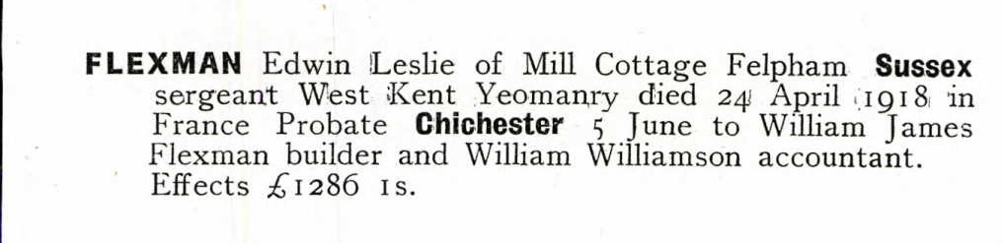

By 1919 William James (Sr) was Clerk of Works to a local Felpham builder who developed much of the area around Sea Road.

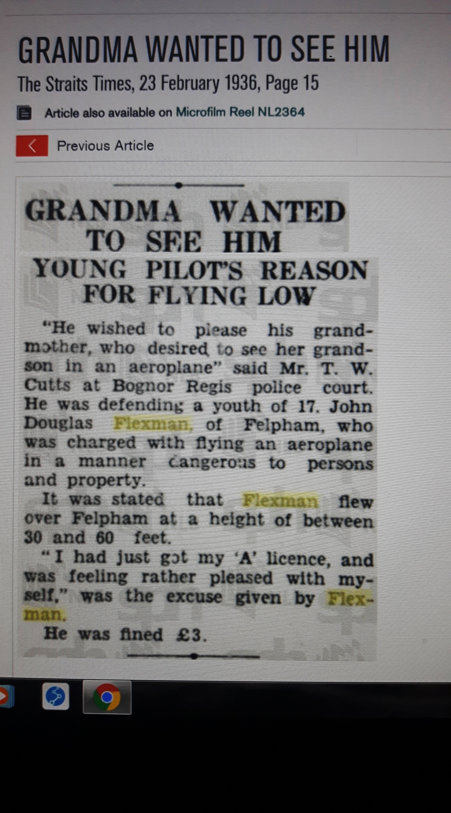
1939 Register for John D. Flexman at “Bramble Cottage Kingsmead..
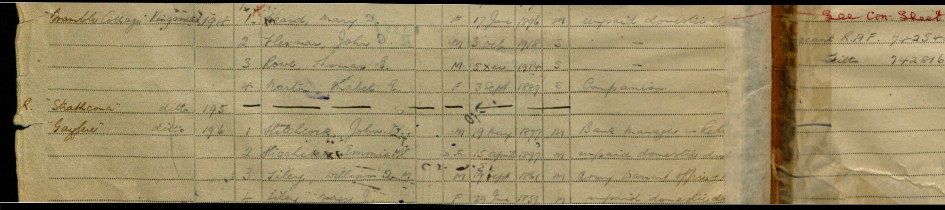

Edwin’s youngest brother William James (Jr) died in on 14th December 1941 at the battle of El Alamein whilst serving as Trooper 7925277 with the 8th Army, Royal Armoured Corps. His name is on the Alamein memorial, column 14. He was 35. One family death in each of the two World Wars of the 20th century.
William James (Snr) died in 1937 aged 76 and Matilda died in 1954 aged 89. Both are buried in St. Mary's churchyard at G140. There is a cross on a rough hewn plinth with rectangular kerbstone. There are inscriptions to two of their sons who died in war

